Dear Parents and Carers, Children and Families,
18th May 2020

I hope you are staying safe and well, and are now beginning to get to grips with the new measures effective from Wednesday 14th May regarding how to continue to stay safe during this pandemic.

As I stated on the school website last week, I’m sure after the Prime Minister’s statement, there were lots of questions and thoughts you may have had. We had lots of questions that need clarification too.
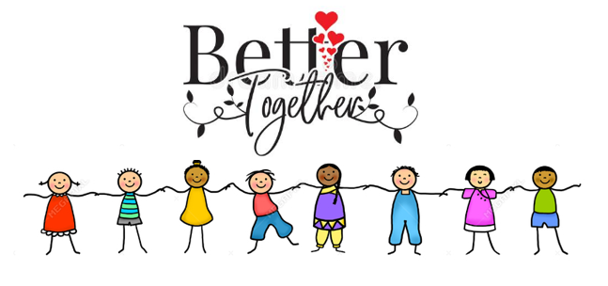
We continue to provide care for those parents whose work is critical to the COVID-19 response and only those that cannot be safely cared for at home. The message is still that it is safer to stay at home.

We still await clear guidance to support our planning and how it is possible to social distance in schools and keep our children, teachers and families safe; how we might start to phase groups of children returning and what this looks like. Please be assured there is no way we will reopen until we are 100% prepared.
As always, we will keep you informed, but for now, please try not to worry. Our plan for now is to continue to provide activities for learning at home, keep in contact with our families, and continue to support each other in these very difficult and uncertain times. Once we are able, we will share our proposed plans with you.

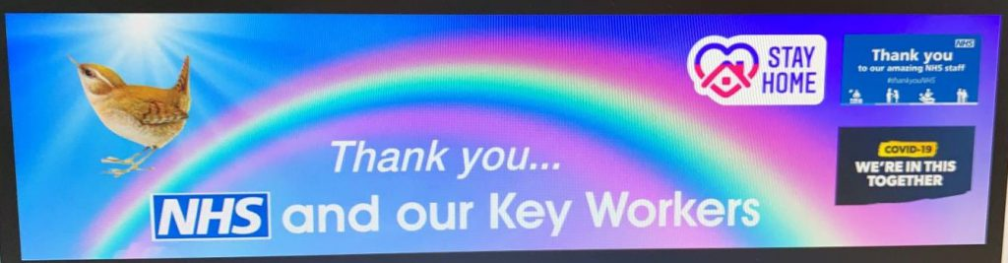
I hope you have seen on our Website and on Parent Hub, the personalised banner we have had specially made for Wren’s Nest to say a
HUGE ‘thank you’ to all of those people on the front line of Covid 19.
I have included a couple of photographs just so you can be as proud of Wren’s Nest as I am.
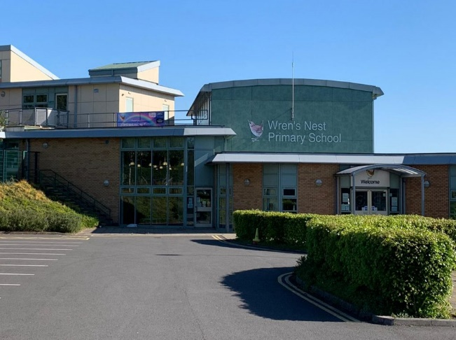
We also have many ‘Stay at home heroes’ helping during this time – and that is you! Thank you for the part you are playing in beating this virus.
We are all in it together!
As always, I remain hopeful and in great anticipation of the day we can open the doors of Wren’s Nest again, to all of our children, parents and wider community and welcome you back with open arms.
Mrs Parkes’ ideas for the week:
- On 20th May, at 8pm (or before bedtime), clap or make some noise (I will use a saucepan and spoon!) for all of the Teachers and school staff that are helping others at this time.
- Stay fit and healthy – exercise everyday – by going for a walk, with your household only, exercise in the garden or in a safe space in your home. Join in with one of our challenges on the website to help you. Look for our ‘Workout Wednesday’ challenge.
- ‘Get Cooking’ - what wonderful creation will you make?

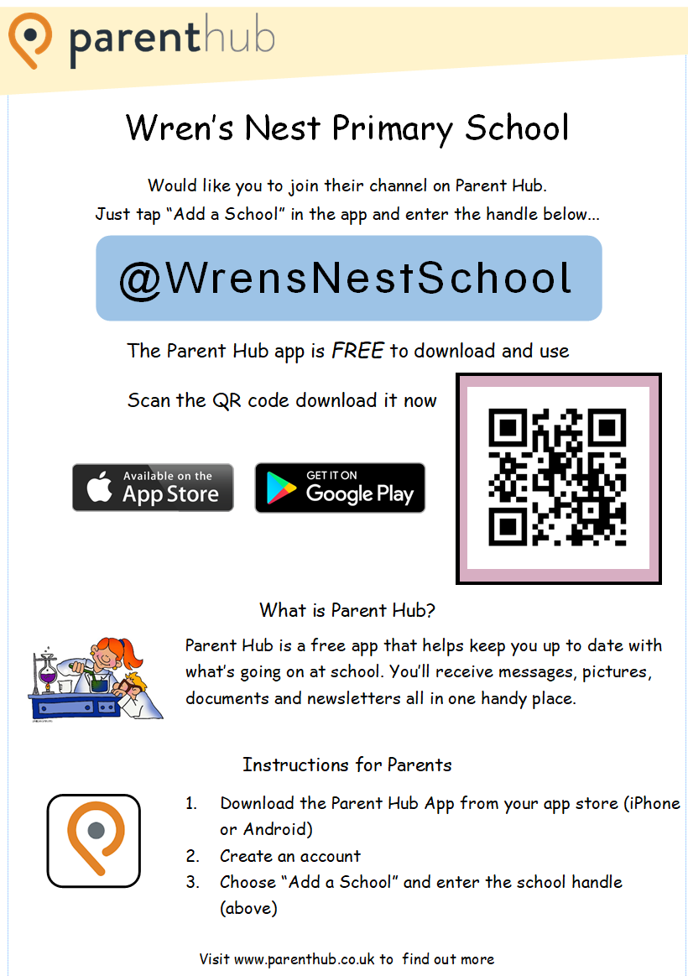
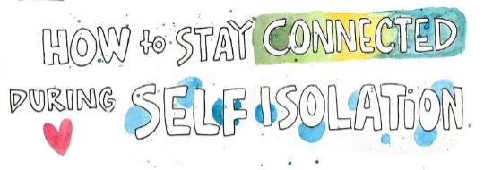

Parent Hub!
Please, if you are not on Parent Hub, download
the FREE App on your phone today! Please scan the QR code using your camera device on your phone and it will take you directly to the link for the app.

It is an excellent way to keep up to date with
everything that is happening at Wren’s Nest,
particularly at this difficult time.

It will suggest ideas for you to do at home as well as keep you updated with key information from school.

LOOK! Below are a few of the activities that we are doing online to support you at home during these unprecedented times. The school website is
www.wrens-nest.dudley.sch.uk
The activities on our website include:
- NEW!! Workout Wednesday Fitness Games – Alphabet Challenges - to help us in staying fit and healthy!
- Listening to stories grown-ups have read.
- NEW!! Magic Mathematicians – take part in lots of activities for you to complete at home
- Super Scientists
- NEW!! Get Cooking – ideas for you to do at home!
- Listen to some special messages from your teachers
We really do hope you take part in and enjoy them!
As always, it remains very important that we continue to support our families during this very uncertain time. Our school mobile phone is continuing to be held either by myself or another member of the Senior Leadership Team and is a way of contacting us, should you need to, so we can provide you with appropriate help and assistance. The mobile number is: 07858 986604
Take care of yourselves, PLEASE remember we are here if you need us.
I hope to see you all very soon – take care! Love, Mrs Parkes x

